Build Instructions for the

Ariadne Spoken Dialogue System

1 Download

First thing after download to do is to decide on a directory (such as c:/ariadne) in which to place the software packages. We will refer to this directory as <root dir> in what follows. You will need about 120 Mbytes of available disk space for the ariadne distribution only.

Unpacking all the zip files in <root_dir> directory will allow you to grep for strings in the entire source code and not to have to adjust include paths in the compiler setup. These setup instructions assume that all zip packages will be unzipped in the <root_dir> directory. After downloading and unzipping, the directory should look like this:

$ cd <root dir>

$ ls
ariadne base data doc ext java js

In addition, the following software package are required: MS Sapi 5.1, Cygwin and (depending on your application) a Java SDK. Download and installation instructions for these packages are below. These packages, if not installed, require additional disk space in addition to the Ariadne distribution. Also, it is recommended that you download and install the Microsoft .Net Speech API Beta 3.

In order to compile the dialogue system, you need MS Visual C++ 6.0 or MS Visual C++ 7.0. Furthermore, I assume that you have the Cygwin shell installed. Note that it is possible to compile and run Ariadne without Cygwin. However, if you don’t have it already it is highly recommended that you install it, it is very useful. Besides, all commands in the examples have been tested with Cygwin; if you use another shell, you may have to adapt the syntax slightly.

2 Installation of required Software

In order to build Ariadne, you need to have several software packages installed. Make sure the required software is on your machine before proceeding. Here is what’s needed.

- Microsoft Speech API 5.1
The SAPI package can be downloaded from http://www.microsoft.com/speech/. Follow the standard install instructions; feel free to place the installation directory anywhere you like. Note the location of the sapi.lib library; you will need that information later.

- Java Standard Edition.
If you would like to interface the dialogue system with java programs, download and install the Java Standard Edition SDK from http://java.sun.com .

- Cygwin shell (Optional, but recommended).
The Cygwin package can be installed directly from the web from http://sources.redhat.com/cygwin/ . Follow the installation instructions; feel free to place the installation directory anywhere you like.

- Microsoft Speech API 4.0 (Optional)
There is a library that allows to access SAPI 4.0 compliant speech synthesizers. It is not necessary to use SAPI 4.0 synthesizers for a fully functional dialogue system; however, if you have one that you do want to use you need the SAPI 4.0 SDK from Microsoft. The SAPI package can be downloaded from http://www.microsoft.com/speech/. Follow the standard install instructions; feel free to place the installation directory anywhere you like. Note the location of the speech.lib library; you will need that information later.

The purpose of the SAPI 4.0 support is primarily to be able to interface to the TTS engines that can be downloaded from the Microsoft Agents web page at http://www.microsoft.com/msagent.

The Ariadne distribution comes with the mozilla spidermonkey JavaScript engine. This can be found in the directory <root dir>/js. No additional steps are necessary to build the included JavaScript engine; all dependencies and paths are set as necessary.

3 Setting up the Ariadne Workspace for Microsoft Visual C++ 6.0
In Microsoft Visual C++ 6.0, open the workspace

<root dir>\ariadne\workspace\msvc6\ariadne.dsw.

Before compiling, you will need to update the paths to some of the packages installed in step 1.

In order to setup the Sapi include files and library, select the ardio_sapi51 project in the left hand pane of the Project Settings box. Now, click on the C/C++ tab and choose Preprocessor from the drop down box. In the field called ‘Additional include directories’, scroll to the right and adapt the path to the Sapi include files according to your setup, as show in the screen shot below.

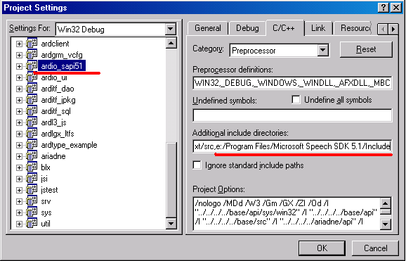

Then, specify that ardio_sapi51 be linked against sapi.lib. To do that, click on the Link tab, and select Input from the dropdown list. Change the path for sapi.lib according to your setup and add sapi.lib and the path to sapi.lib in the appropriate fields as shown in the screen shot below.

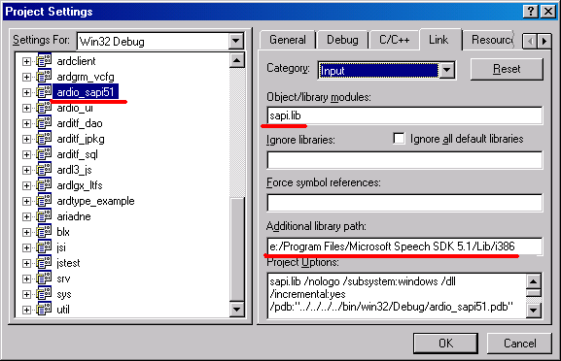
When you are done, dismiss the Settings dialog box by clicking OK. Set __All as the active project (this is a dummy project that depends on all the projects necessary for a complete Ariadne build so as to ensure that all files needed are created) and select File -> Save workspace. This concludes the workspace setup.

SAPI 4.0
If you do not want to use SAPI 4.0 compliant speech synthesizers, please delete the project ardio_sapi40 from your workspace. The remaining projects are sufficient to build a complete dialogue system. However, if you do want to use a SAPI 4.0 compliant synthesizer, please adapt the search and library paths for the ardio_sapi40 project as you did for the sardio_sapi51 project.

4 Setting up the workspace for Microsoft Visual C++ 7.0

Please be aware that you need Unicode MFC libraries in order to Ariadne to compile. You can select Unicode MFC libraries during installation or maintenance of Visual C++ 7.0 in the screen shown below.
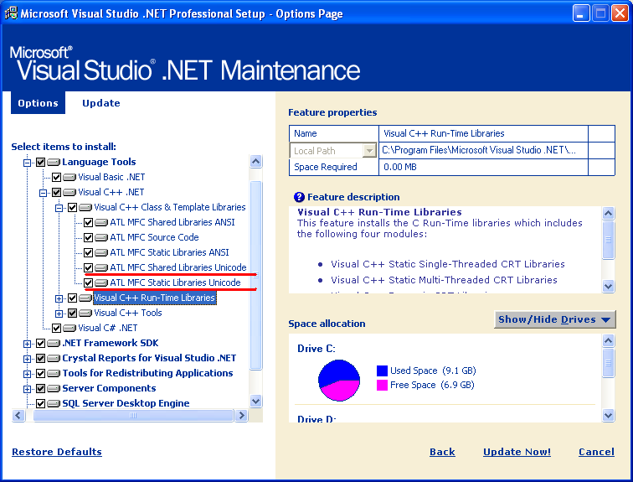

In Microsoft Visual C++ 7.0, open the workspace

<root dir>\ariadne\workspace\msvc7\ariadne.vcproj.
As in Visual C++ 6.0, you need to specify the location of the include files and libraries for the SAPI projects. To do that, right-click on the ardio_sapi51 project and select the Properties menu. In the dialog box that appears, select the C/C++ Folder and the General entry in that folder. In the Additional Include Directories entry, replace the path name with the path where your SAPI5.1 include files are located.
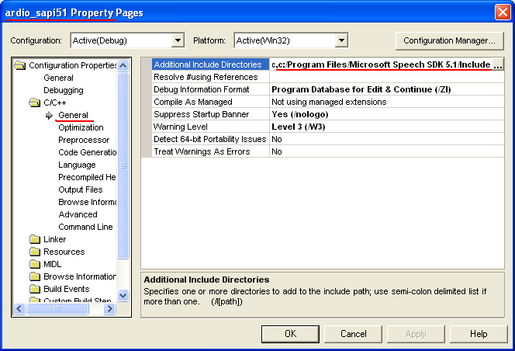

Then, open the Linker folder and select the General entry. In the Additional Library Directories on the right, replace the SAPI directory with the directory that contains the SAPI library on your system.
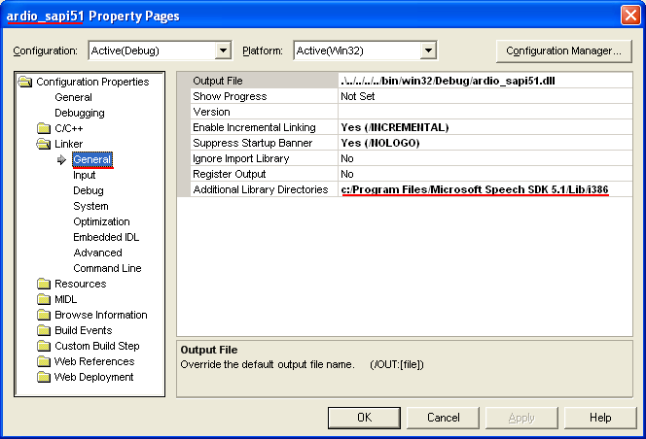

5 Building and testing Ariadne
If everything was done properly in the previous steps, you should be ready to build Ariadne. To start the build in MS Visual Studio, select Rebuild All from the Build menu or hit F7 to build the system.

After a successful build, the dlls and executables are located in
<root dir>/bin/win32/Debug. In order to test the system, switch to a shell window and type:

$ cd <root dir>/bin/win32/Debug

$ ./ariadne ../../../data/tutorial/step01/step01.cfg English

The first argument is the configuration file in which all paths and other parameters necessary for the dialogue system are declared. The second argument is the language in which the grammars are written. When the window pops up and the initialization stops, you can type ‘hello’ or ‘bye bye’ in the command line and press the ‘Process’ button. The system should respond.

The tutorial configuration files assume that you have the Microsoft .Net Speech SDK Beta 3 installed. If not, Ariadne will stop and display a list of available speech recognizers on your system. You will have to edit the configuration file you passed as command line argument and replace the recognizer name with one of the names displayed here.

6 Building the JAVA Application Interface
Ariadne provides an easy way to interface with JAVA applications. There are generic classes that handle the communication between the dialogue system and the application. These classes are located in <root dir>/java/edu/cmu/cs/is/ariadne. In order to build them do the following in the shell.

$ cd <root dir>/java/edu/cmu/cs/is/ariadne

$ javac *.java

Note that javac.exe might not be in your search path. If the last command line triggers the error message bash: javac: command not found make sure that you have the complete Java SDK installed (not only the run time edition) and that javac.exe is in your search path.

If you got so far….

Congratulations! You have successfully completed the installation of Ariadne. For more information, please see the <root dir>/doc directory.

7 Compiler Generation with Flex and Bison

This step is optional. It is not necessary to execute this step for a working Ariadne system.

As you will learn in the tutorial, the dialogue system takes an application description language as input to dynamically generate dialogues. The compiler for the files written in that application description language is built with the help of the compiler generation tools flex and bison (the Windows equivalents of the well-known tools lex and yacc).
The setup described above was a little bit simplified in that the build process relies on precompiled files generated by flex and bison. This means that if you choose to modify the application description language, you will have to tell the compiler how to rebuild the needed files. Here is how this is done.

First, you will have to download and install the Cygwin shell, if you haven’t done so. Make sure you select bison and flex during the install process when the ‘Select Packages’ dialog box appears (expand the ‘devel’ entry and check flex and bison). If you have Cygwin already installed and flex.exe and bison.exe are missing, just run the installer again; it is smart enough to figure out what you need. After installation, you will have to determine the location of the bison.exe and flex.exe programs (you might want to use the Windows Search function); you will need that information later.

Next, you will have to tell MS VC++ where to find the bison.exe and flex.exe programs as well as the Sapi include files and library. To do that, go to Project -> Settings, select the file

ardc/desc/DialoguePackage.lex.cpp

in the left hand pane of the project settings box, uncheck the Exclude from Build check mark, select the Custom Build tab and add the following commands and output paths in the respective fields, as shown in the screen shot below.

Commands (no line break):

e:\cygwin\bin\flex
-o..\..\..\..\ariadne\src\ardc\desc\DialoguePackage.lex.compiled ..\..\..\..\ariadne\src\ardc\desc\DialoguePackage.lex.cpp

Output:

..\..\..\..\ariadne\src\ardc\desc\DialoguePackage.lex.compiled

You will need to adapt the underlined path according to your local setup.
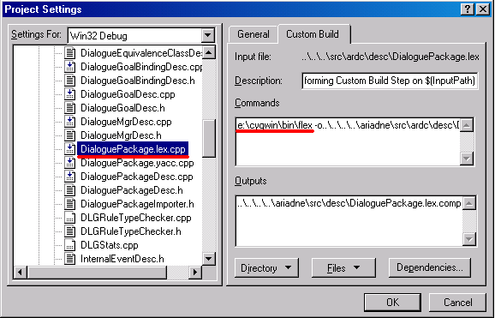

Then, repeat this step for the file ardc/desc/DialoguePackage.yacc.cpp and bison.exe.

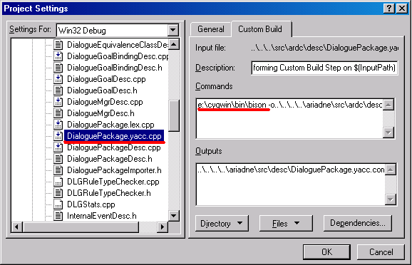

The commands and outputs for bison are:
Commands (no line break):

e:\cygwin\bin\bison
-o..\..\..\..\ariadne\src\ardc\desc\DialoguePackage.yacc.compiled ..\..\..\..\ariadne\src\ardc\desc\DialoguePackage.yacc.cpp

Outputs:
..\..\..\..\ariadne\src\ardc\desc\DialoguePackage.yacc.compiled

